CS 340 README Project Two

About the Project/Project Title
This project is the second phase of the full-stack application developed for Grazioso Salvare, a company that specializes in training search-and-rescue dogs. Building on the CRUD module from Project One, this phase focuses on creating an interactive dashboard that allows users to visualize, filter, and explore animal data from the Austin Animal Center Outcomes database.
The dashboard is built using Python, Dash, Plotly, and Dash Leaflet. It connects to the MongoDB database through the AnimalShelter CRUD class and provides real-time filtering, geolocation mapping, and breed distribution visualizations. This tool helps Grazioso Salvare quickly identify animals that meet specific criteria for different types of rescue training.

Motivation
The motivation behind this project is to transform raw database access into a functional, user-friendly interface that supports decision-making. Grazioso Salvare needs a way to:
- Filter animals by rescue category
- View breed distributions
- Select individual animals and see their geolocation
- Interact with the data visually and intuitively
By building this dashboard, I learned how to integrate backend data with frontend components, use Dash callbacks to create dynamic interactions, and visualize real-world data in meaningful ways. This project completes the full pipeline from database to user interface.

Getting Started
To reproduce this project, the MongoDB database must be set up in Codio and the dataset imported. Since the Codio environment for Project Two does not use authentication, the dashboard connects without a username or password.
1. Import the Dataset
Navigate to the dataset folder:
cd ~/workspace/datasets
Import the CSV file into MongoDB:
mongoimport --db aac --collection animals --type csv --headerline --file aac_shelter_outcomes.csv
2. Verify the Database
Enter the Mongo shell:
mongosh
Switch to the database:
use aac
Check that documents exist:
db.animals.countDocuments()
You should see approximately 10,000 records

Installation
To run this project, the following tools and libraries are required:
- Python 3.x
- MongoDB (Codio environment)
- PyMongo
- Dash / JupyterDash
- Plotly Express
- Dash Leaflet
- Pandas
- Jupyter Notebook
Install required packages:
pip install pymongo dash dash-leaflet plotly pandas
Usage
The dashboard uses the AnimalShelter CRUD class to retrieve data from MongoDB and display it in an interactive interface. Features include:
- DataTable with sorting, filtering, and row selection
- Pie chart showing breed distribution
- Geolocation map showing the selected animal’s coordinates
- Radio button filters for rescue categories:
  - Water Rescue
  - Mountain/Wilderness Rescue
  - Disaster/Individual Tracking
  - Reset (All Animals)
Connecting to the Database
Because authentication is not used in Project Two, the dashboard connects like this:
db = AnimalShelter()
Running the Dashboard
In JupyterLab (inline mode):
app.run_server(mode='inline', port=8050, debug=True);
Or in external browser mode:
app.run_server(debug=True)

Screenshots:
Full dashboard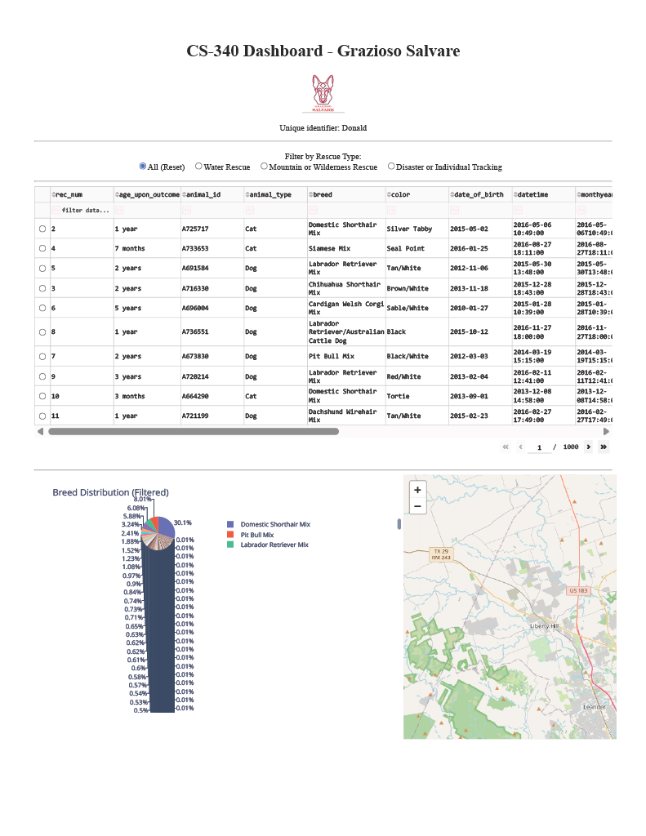

Water Rescue
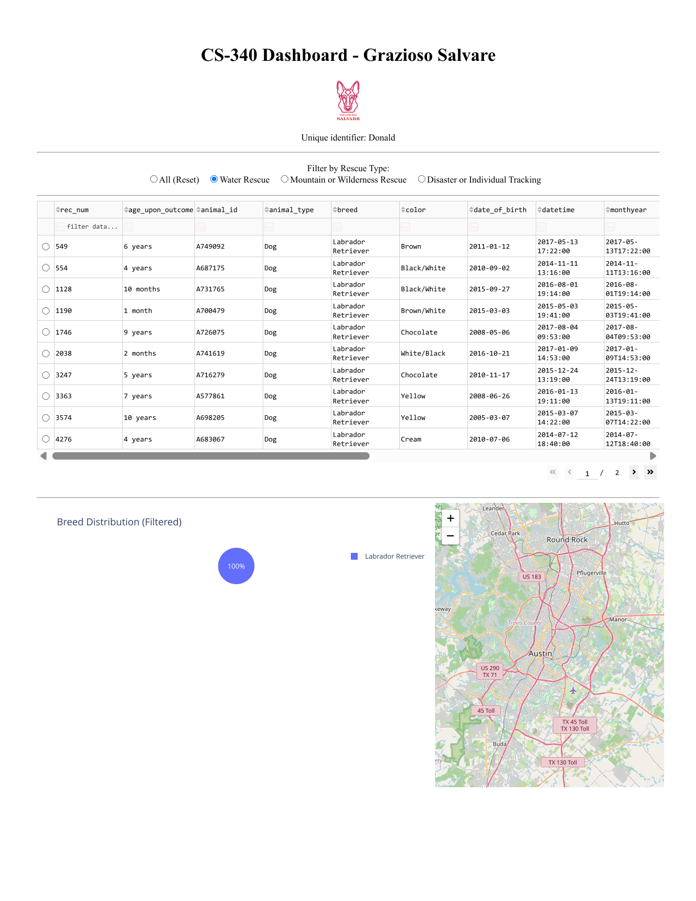
Mountain or Wilderness Rescue
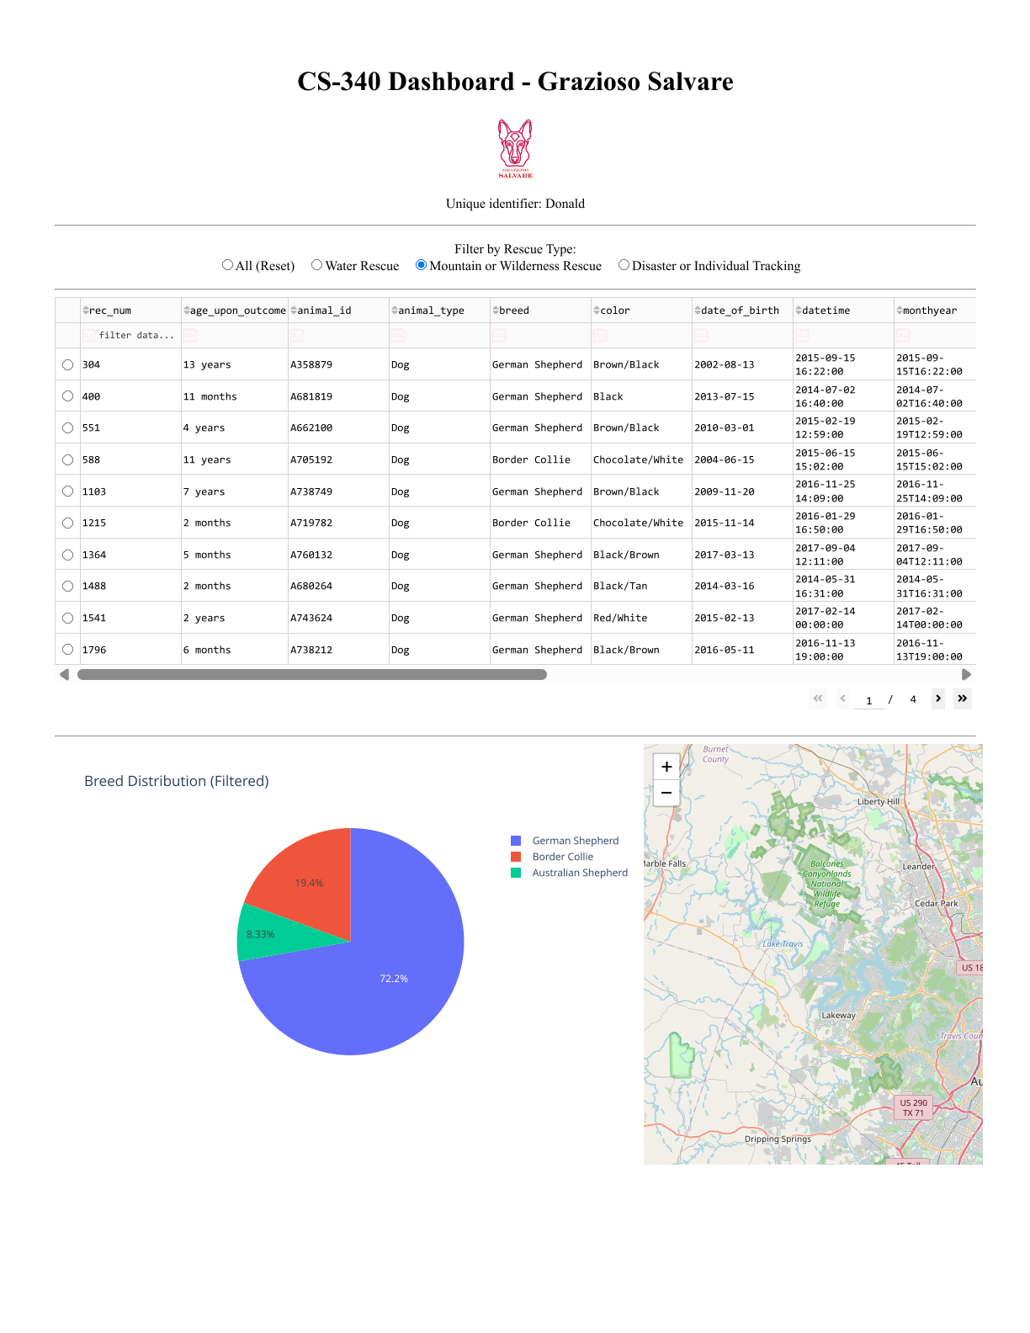

Disaster or Individual Tracking
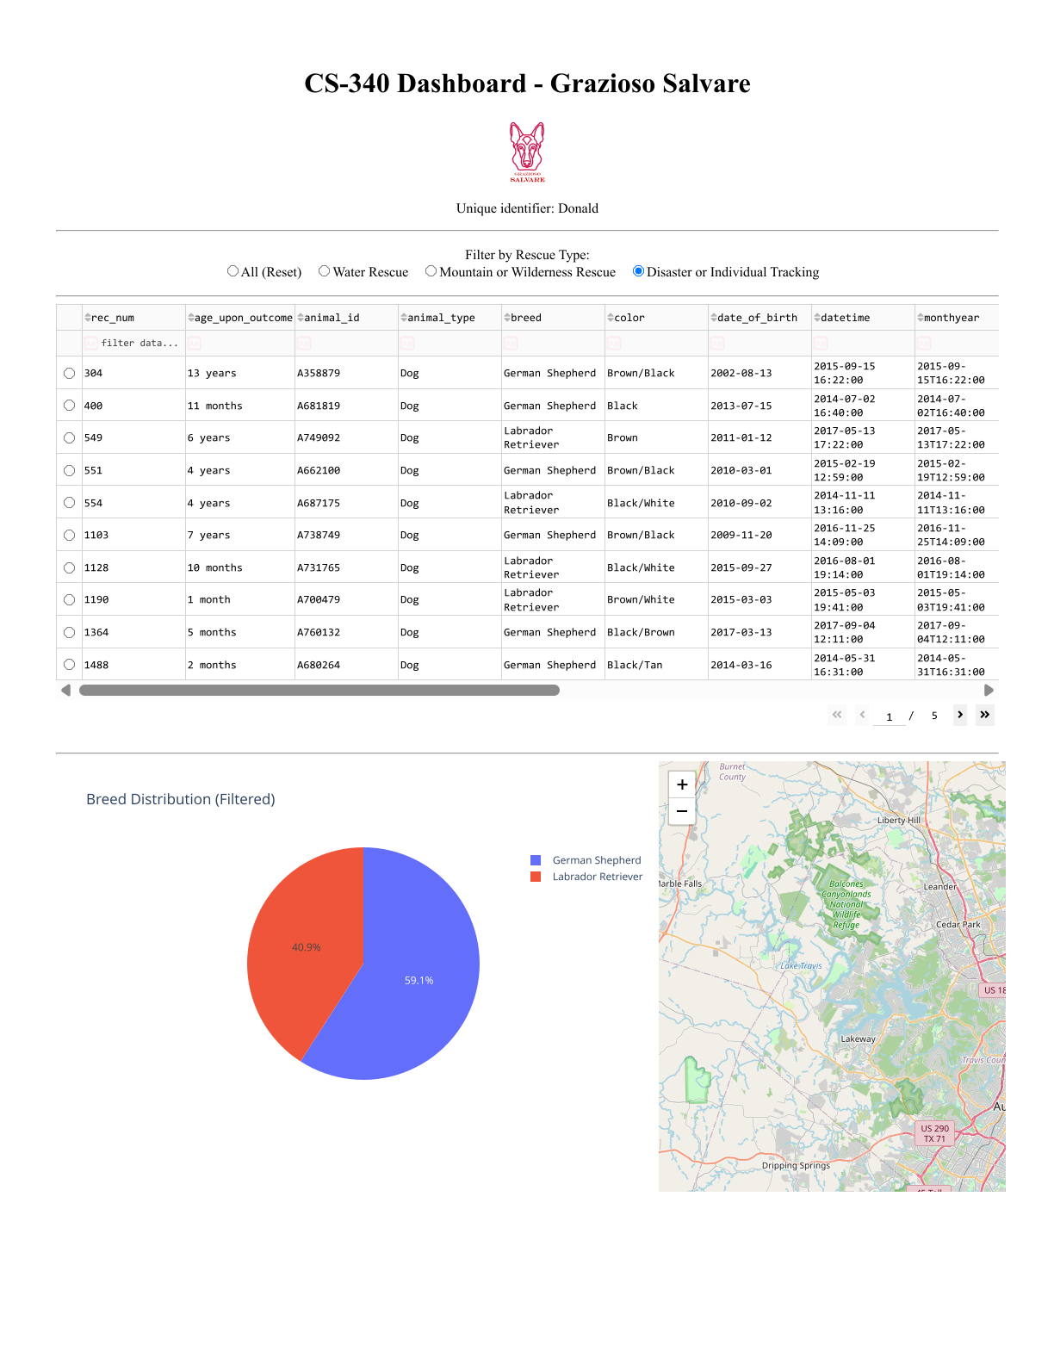
Code cell showing the dashboard running
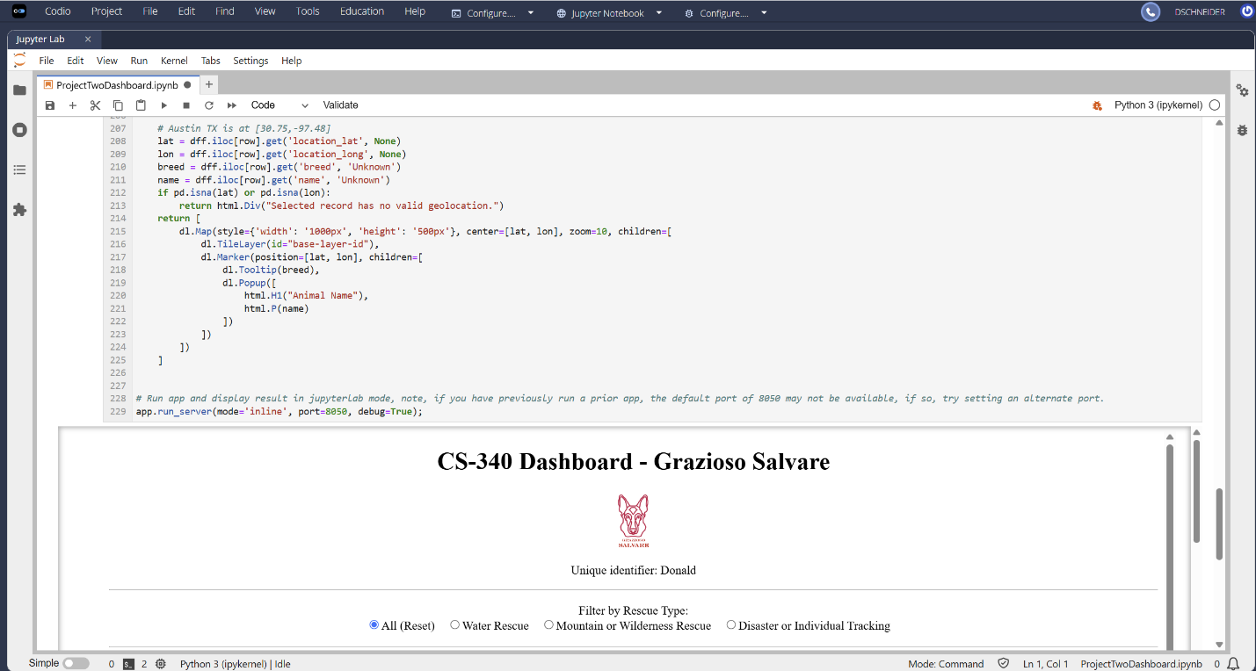

Contact
Name: Donald Schneider

